**Pong Design Doc**

To-do List:

* Draw Ball and Paddles
* Move ball
* Check for collision with all edges
* Invert y axis transform on collision with top and bottom according to WINDOW_HEIGHT
* Move players paddles
* Check for collision with paddles, Invert x axis transform
* Check for collision with left and right according to WINDOW_WIDTH, add scoring based on each side and reset game loop

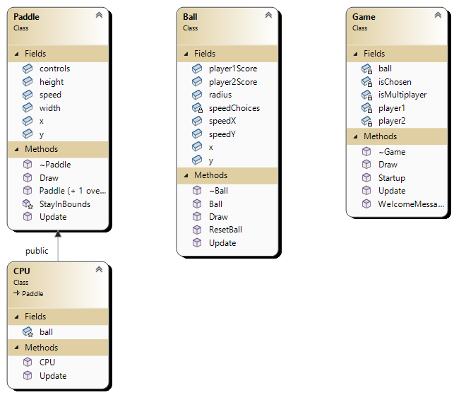

**Class Descriptions:**

* Game

This class handles initialising the objects in the game, as well as updating and drawing said objects. There is also the added functionality of the start screen which will ask the player if they would like to play two player local multiplayer or singleplayer against the computer. This is handled as a polymorphic instantiation of player2.

* Ball

The ball handles its own direction and speed as well as checking for collisions, changing its direction accordingly. Should the ball collide with the side walls, it will reset itself and increment the score of the corresponding player.

* Paddle

The paddle is a simple rectangle which the player(s) can control to move along its Y axis. The paddle is initialised with keyboard keys which are held in an array to be the player’s controls. An attempt was made to allow the players to input which keys they wanted to use as their controls, but this functionality had to be cut from the project for being out of scope.

* CPU

This class inherits from Paddle, as it is just a standard paddle which is polymorphically initialised during single player games and uses a simple AI which attempts to follow the Y axis of the ball.